|  |  |
| --- | --- |
| **EX NO:1**  **DATE:** | **TO RECOGNIZE VARIOUS COMPONENTS OF PC INPUT OUTPUT SYSTEMS PROCESSING AND MEMORY UNITS** |

**Aim:** To Recognize Various Components of PC- Input Output Systems Processing and Memory Units

**Theory:**

The basic components of a PC are

1. Input Unit

2. Output unit

3. Memory unit

4. Control unit

5. Arithmetic logic unit

## Input Unit:

It is the unit through which data/instructions can be entered into the computers.

e.g. Keyboard, Mouse etc.

## Output Unit:

It is the unit by which we can get output from the entered input from the computer.

e.g. Monitors, Printer, Speaker etc.

## Memory Unit:

It stores the information by providing facility to the CPU actively by providing necessary data to CPU.

## Memory Units are of two types

1. Primary memory

2. Secondary memory.

**Primary Memory:** It is also of two types:

1. RAM
2. ROM

**RAM:** It can be randomly accessed.

Memory is temporarily used because when the power goes off, all the data stored in it are erased. So, it is volatile in nature. It can be read and the data can be written into it.

**ROM:** It is also randomly accessed. It is only read memory unit. It is nonvolatile in nature. It can be read only but data can’t be written into it.

**ALU:** It performs arithmetic operation like addition, subtraction etc., and logical operation like AND, OR, NAND etc. It works in electronic speed but the device attached to it works in low speed. That’s why processor can handle all the peripheral devices at a time. IT establishes well coordination between other four functional units.

**CU:** It is the unit which controls the flow of information through the processor and coordinate the activities the activities of another unit which are within it. So, it is the brain as it controls what happens inside the processor. It generates timing signal and control signal for well coordination.

## Configuration of a PC.

|  |  |  |  |
| --- | --- | --- | --- |
| S.NO | Name of Component | Name of Manufacturer | Capacity/frequency interface |
| 1 | Processor |  |  |
| 2 | Mother Board |  |  |
| 3 | RAM |  |  |
| 4 | HDD |  |  |
| 5 | FDD |  |  |
| 6 | DVD |  |  |
| 7 | TFT/CRT |  |  |
| 8 | Keyboard |  |  |
| 9 | Mouse |  |  |
| 10 | UPS |  |  |
| 11 | Cabinet |  |  |
| 12 | Speaker |  |  |

**Processor:** The microprocessor accepts inputs from the user in the form of data and instruction. It processes the information and instruction and then send the processed information to the output device.

**Motherboard:** It is the main circuit of PC. It contains the interface for the microprocessor, BIOS Memory and storage device need to control peripheral devices such as monitor, keyboard, mouse etc.

**RAM:** It stores data temporarily. So, it is called volatile.

**HDD:** IT is a secondary storage device for permanent data storage device i.e. placed in the system. It is similar to human brain where all the past to present events are stored.

**DVD RAM:** The Digital versatile disc stored digitally. A DVD writer is a DVD player as well as a writer.

**FDD:** It is a n external storage device. It is magnetic round disc enclosed in a plastic jacket. Today we have double size high quality to density disk with 1.44 MB of size.

**Keyboard:** It is a primary input device of the PC similar to type writer.

**Mouse:** It is used to point to the desired position in the computer. It is also an input device.

**UPS:** It is the device that produce supply to the PC. It provides all the time of power cut. So, we can save the current data and shut down properly.

**Speaker:** It is an output device through which CPU can produce sound for the user.

**TFT monitor**: It is an output device through which we can read data.

**Cabinet:** outer covering of CPU.

## Conclusion:

Hence the Reorganization of Various Components of PC- Input Output Systems Processing and Memory Units has been done successfully.

|  |  |
| --- | --- |
| **EX NO:2**  **DATE:** | **PC CONNECTION AND ASSEMBLY** |

**AIM**:

**THEORY**:

**BUSES**:

A bus is a high-speed internal connection. Buses are used to send control signals and data between the processor and other components.

**TYPES OF BUSES:**

Address bus - carries memory addresses from the processor to other components such as primary storage and input/output devices. The address bus is unidirectional.

Data bus - carries the data between the processor and other components. The data bus is bidirectional.

Control bus - carries control signals from the processor to other components. The control bus also carries the clock's pulses. The control bus is unidirectional.

The bus is the route used for peripheral devices to interact with the computer processor. A typical connection of the bus to devices is shown in the figure.

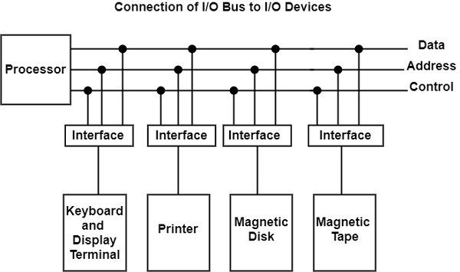

The bus includes data lines, address lines, and control lines. In any general-purpose computer, the magnetic disk, printer, and keyboard, and display terminal are commonly employed. Each peripheral unit has an interface unit associated with it. Each interface decodes the control and address received from the bus.

It can describe the address and control received from the peripheral and supports signals for the peripheral controller. It also conducts the transfer of information between peripheral and processor and also integrates the data flow.

The bus is linked to all peripheral interfaces from the processor. The processor locates a device address on the address line to interact with a specific device. Each interface contains an address decoder attached to the bus that monitors the address lines.

When the address is recognized by the interface, it activates the direction between the bus lines and the device that it controls. The interface disables the peripherals whose address does not equivalent to the address in the bus.

**HOW TO ASSEMBLE A COMPUTER**

The assembling of the computer system is exactly the opposite of disassembling operation. Before starting assembling the computer system, make sure you have the screws and a screwdriver for those.

**STEP 1: MOUNT THE PROCESSOR**

The first step for assembling the computer system starts with mounting the processor on the processor socket of the motherboard. To mount the process, you don't need to apply any force. The special ZIF (zero insertion force) sockets are usually used to prevent any damage to the processor pins. Once the processor is mounted, the heat sink will be attached on top of the processor. The CPU fan is also attached on top of the heat sink.

**STEP 2: FIX THE MOTHERBOARD IN THE TOWER CASE**

Now the motherboard is to be fixed vertically in the tower case and the screws are fixed from behind of the motherboard.

**STEP 3: CONNECT THE POWER SUPPLY**

Now line up the power supply at the top back end of the cabinet and screw it. The power connectors for motherboard power supply and CPU fan power supply are to be connected. If the cabinet cooling FAN is required then it is to be screwed at the back-end grill of the cabinet and its power connector is to be connected from SMPS.

**STEP 4: INSTALL THE DRIVES**

Install the CD/DVD drives at the top front end of the cabinet and screw it. Install the Hard disk drive and floppy disk drive below CD/DVD drive and screw it. Make sure once screwed there is no vibration in either of the CD/DVD, hard disk or floppy disk drives.

**STEP 5: CONNECT CABLES**

Now select the appropriate data cable and connect one end of the cable to its drive socket and another end at its appropriate connector on the motherboard. For SATA hard disk drive or CD/DVD drives use SATA cable and its power cable, else use IDE data cable. Do the proper jumper settings as per the usage requirement.

**STEP 6: MOUNT THE MEMORY MODULES**

It is time now to mount the memory modules on the motherboard by aligning the RAM to its socket on the motherboard and press it downward. Make sure the side tab is fixed into the RAM notch. If not, you may still have to press a bit.

**STEP 7: INSTALL THE INTERNAL CARDS**

Install the internal cards to its socket and attach the cables or power cable to it. The selection of right socket or slot is required as per the type of socket.

**STEP 8: COVER THE TOWER**

Cover the tower by placing it and pressing towards front side and screw it.

**STEP 9: CONNECT THE EXTERNAL DEVICES AND POWER**

Connect the external devices with CPU at its appropriate socket. It includes mouse and keyboard at PS2 or USB connectors. Monitor at the video output socket. Connect the power cable to the back of tower in SMPS. Plug in the power cable to the electric board.

**RESULT**:

|  |  |
| --- | --- |
| **EX NO:3**  **DATE:** | **8086 SIMULATOR** |

**AIM:** 8086 Simulator Addressing modes

**PROCEDURE:**

There in 8086 programming all 8 addressing modes in 8086 programming.

**(I)INTERMEDIATE ADDRESSING MODE:**

The addressing mode in which data operand is a part of instruction is called IAM.

**(II)REGISTER ADDRESSING MODE:**

It means that register is a source of operand for instruction.

Example: MOVCX, AX.

**(III) DIRECT ADDRESSING MODE:**

The addressing mode in which the effective address of the memory location is written directly. Example: MOVAX, [C1592H]

**(IV) REGISTER INDIRECT ADDRESSING MODE:**

This allows data to be addressed at any location through an offset address.

**(V) BASED ADDRESSING MODE:**

In this mode, offset address of the operand is given by the Sum contents of BXIBP registers. Example: MOVDX, [ BX +04]

**(VI) INDEXED ADDRESSING MODE:**

The operands offset address is found by adding the contents of SII Di address.

Example: MOVBX, [ S1 + 16] TALIAN

**(VI) BASED INDEX ADDRESSING MODE:**

The operands offset is computed by adding base register to continues of Index register.

Example: ADDCX, [AX +51]

**(VIII) BASED INDEXED WITH DISPLACEMENT MODE:**

The operands offset is computed by adding the base register contents.

Example: MOVAX, [ BX + D # + 08]

**RESULT**:

|  |  |
| --- | --- |
| **ExNo:4**  **DATE:** | **Program involving Arithmetic Instructions on 8-bit data- Addition** |

**AIM:** To implement assembly language program for addition of two 08-bit numbers.

**ALGORITHM:**

1. Load the first number from memory location 2050 to accumulator.
2. Move the content of accumulator to register H.
3. Load the second number from memory location 2051 to accumulator.
4. Then add the content of register H and accumulator using “ADD” instruction and storing result at 3050
5. The carry generated is recovered using “ADC” command and is stored at memory location 3051

**APPARTUS:** TASM Software, P.C.

# PROGRAM:

DATA SEGMENT

A DB 09H

B DB 02H

C DW ? DATA ENDS

CODE SEGMENT

ASSUME CS:CODE,DS:DATA START:

MOV AX, DATA MOV DS, AX MOV AL, A MOV BL, B ADD AL, BL MOV C, AX

INT 3

CODE ENDS END START

|  |  |
| --- | --- |
| **ExNo:4**  **DATE:** | **ii) Program involving Arithmetic Instructions on 8-bit data- subtraction** |

**AIM:** To implement assembly language program for subtraction of two 08-bit numbers.

**ALGORITHM:**

1. Load 00 in a register C (for borrow)
2. Load two 8-bit number from memory into registers
3. Move one number to accumulator
4. Subtract the second number with accumulator
5. If borrow is not equal to 1, go to step 7
6. Increment register for borrow by 1
7. Store accumulator content in memory
8. Move content of register into accumulator
9. Store content of accumulator in other memory location

10. Stop

**APPARTUS:** TASM Software, P.C.

# PROGRAM:

DATA SEGMENT

A DB 09H

B DB 02H

C DW? DATA ENDS

CODE SEGMENT

ASSUME CS: CODE, DS:DATA START:

MOV AX, DATA MOV DS, AX MOV AL, A MOV BL, B

SUB AL, BL MOV C, AX INT 3

CODE ENDS END START

|  |  |
| --- | --- |
| ExNo:5iDATE | Program involving Arithmetic Instructions on 16-bit data- Addition |

# PROGRAM:

DATA SEGMENT N1 DW 1234H

N2 DW 2134H RES DW?

DATA ENDS CODE SEGMENT

ASSUME CS: CODE, DS: DATA START: MOV AX, DATA

MOV DS, AX MOV AX, N1 MOV BX, N2 ADD AX, BX MOV RES, AX INT 21H CODE ENDS END START

# RESULT:

AX = 3368h

|  |  |
| --- | --- |
| ExNo:5iiDATE | Program involving Arithmetic Instructions on 16-bit data- Subtraction |

**AIM:** To implement assembly language program for subtraction of two 16-bit numbers.

**ALGORITHM:**

1. Get the LSB in L register and MSB in H register of 16 Bit number.
2. Exchange the content of HL register with DE register.
3. Again, Get the LSB in L register and MSB in H register of 16 Bit number.
4. Subtract the content of L register from the content of E register.
5. Subtract the content of H register from the content of D register and borrow from previous step.
6. Store the result in memory location.

**APPARTUS:** TASM Software, P.C.

# PROGRAM:

DATA SEGMENT N1 DW 4444H

N2 DW 2121H RES DW?

DATA ENDS

CODE SEGMENT

ASSUME CS: CODE, DS:DATA START: MOV AX, DATA

MOV DS, AX MOV AX, N1 MOV BX, N2 SUB AX, BX MOV RES, AX INT 21H CODE ENDS END START

# RESULT:

AX = 2323h

|  |  |
| --- | --- |
| Ex No: 6 iDATE | Program involving Arithmetic Instructions on 16-bit data- Multiplication |

**AIM:** To implement assembly language program for Multiplication of two 16-bit numbers.

**ALGORITHM:**

1. Load the first data in the HL pair.
2. Move content of HL pair to the stack pointer.
3. Load the second data in the HL pair and move it to DE.
4. Make H register as 00H and L register as 00H.
5. ADD HL pair and stack pointer.
6. Check for carrying if carry increment it by 1 else moves to the next step.
7. Then move E to A and perform OR operation with accumulator and register D.
8. If the value of the operation is zero, then store the value else go to step 3.

**APPARTUS:** TASM Software, P.C.

# PROGRAM:

DATA SEGMENT

A DW 1234H

B DW 5678H

C DD? DATA ENDS

CODE SEGMENT

ASSUME DS:DATA, CS: CODE START:

MOV AX, DATA MOV DS, AX MOV AX, A MOV BX, B MUL BX

INT 3

CODE ENDS END START

|  |  |
| --- | --- |
| Ex No: 6 iiDATE | FACTORIAL OF A GIVEN NUMBER |

## PROGRAM:

DATA SEGMENT A DB 5

DATA ENDS CODE SEGMENT

ASSUME DS:DATA, CS: CODE START:

MOV AX, DATA MOV DS, AX MOV AH,00 MOV AL, A

L1: DEC A MUL A MOV CL, A CMP CL,01 JNZ L1

MOV AH,4CH INT 21H

CODE ENDS END START

Input: 5 Output: 0078H

|  |  |
| --- | --- |
| EXPERIMENT: 07 |  |
| DATE: | **STUDY OF HALF ADDER AND FULL ADDER** |

**AIM:**

To realize Half Adder and Full Adder using Basic gates.

_ To realize the half adder circuits using basic gates.

_ To realize full adder using two half adders.

**COMPONENTS REQUIRED:**

IC 7408, IC 7486, IC 7432, Patch Cords & IC Trainer Kit.

**THEORY:**

Adder circuit is a combinational digital circuit that is used for adding two numbers. A typical adder circuit produces a sum bit (denoted by S) and a carry bit (denoted by C) as the output. Typically, adders are realized for adding binary numbers but they can be also realized for adding other formats like BCD (binary coded decimal, XS-3 etc. Besides addition, adder circuits can be used for a lot of other applications in digital electronics like address decoding, table index calculation etc. Adder circuits are of two types: Half adder ad Full adder.

**Half-Adder:** A combinational logic circuit that performs the addition of two data bits, A and B, is called a half-adder. Addition will result in two output bits; one of which is the sum bit, S, and the other is the carry bit, C.

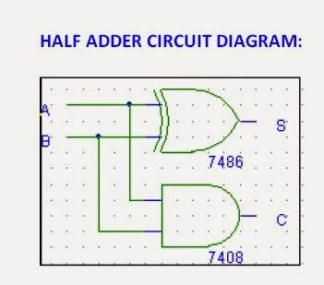

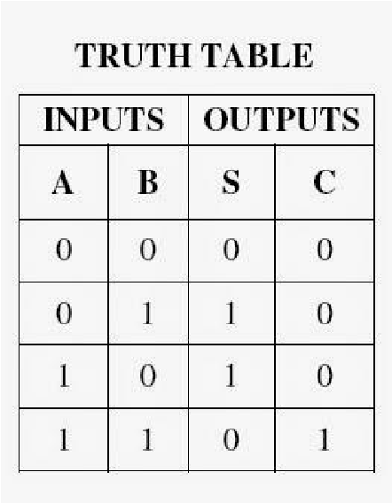The Boolean functions describing the half-adder are:

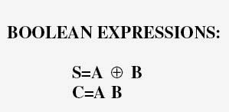

**Full-Adder:** The half-adder does not take the carry bit from its previous stage into account. This carry bit from its previous stage is called carry-in bit. A combinational logic circuit that adds two data bits, A and B, and a carry-in bit, Cin , is called a full-adder.

The Boolean functions describing the full-adder are:

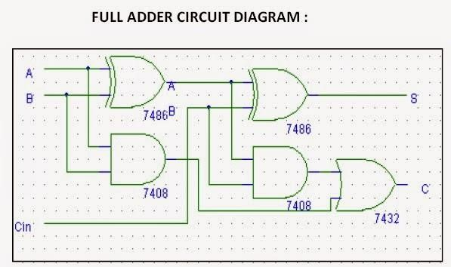

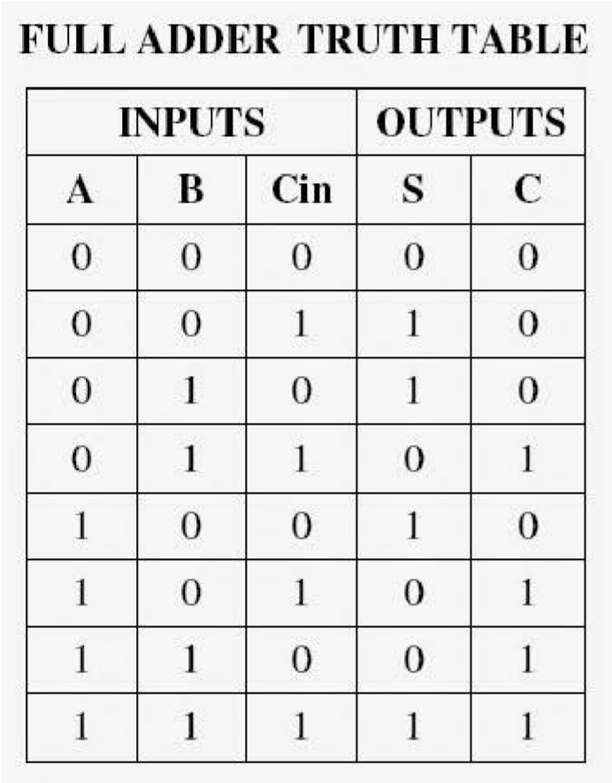

**RESULT:**

Thus, the study of half adder and full adder has been done and components has been realized.

|  |  |
| --- | --- |
| EXPERIMENT: 08 |  |
| DATE: | **STUDY AND DESIGN OF RIPPLE CARRY ADDER** |

**AIM:**

-To realize ripple, carry adder using Basic gates.

_ To realize the ripple, carry adder circuits using basic gates.

_ To realize ripple, carry adder using four full adders.

**COMPONENTS REQUIRED:**

IC 7408, IC 7486, IC 7432, Patch Cords & IC Trainer Kit.

**THEORY:**

A ripple carry adder also known as “n-bit parallel adder” is a combinational logic circuit used for the purpose of adding two n-bit binary numbers and requires ‘n’ full adders in the circuit.

**4-BIT RIPPLE CARRY ADDER-**

4-bit ripple carry adder is used for the purpose of adding two 4-bit binary numbers. In mathematics, any two 4-bit binary numbers A3A2A1A0 and B3B2B1B0 will be added as-

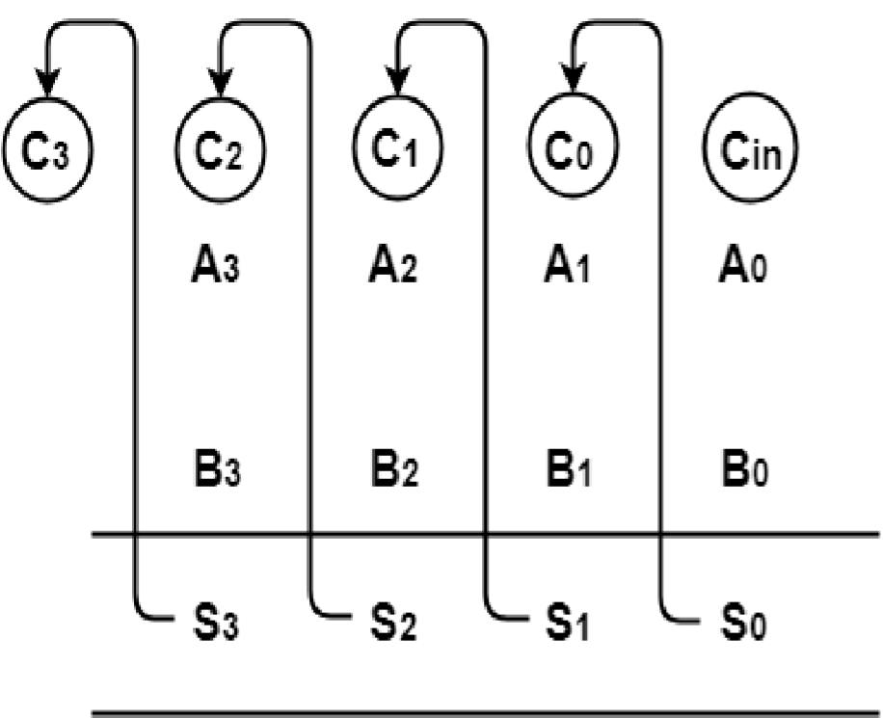

Using ripple carry adder, this addition will be carried out as shown by the following logic diagram-

Using ripple carry adder, this addition will be carried out as shown by the following logic diagram-

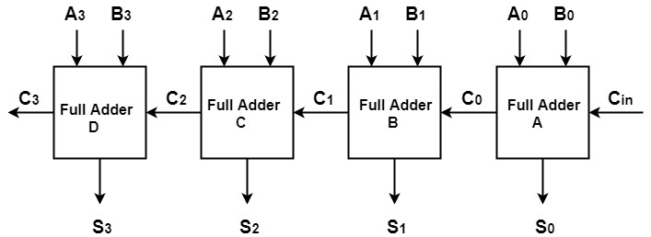

**LOGIC DIAGRAM FOR 4-BIT RIPPLE CARRY ADDER**

As shown, Ripple Carry Adder works in different stages where the carry out produced by each full adder as output serves as the carry in input for its adjacent most significant full adder. When the carry in becomes available to the full adder, it activates that full adder and it comes into operation.

• Output Sum = S3S2S1S0 = 1111

• Output Carry = C3 = 0

**WHY RIPPLE CARRY ADDER IS CALLED SO?**

•In Ripple Carry Adder, the carry out produced by each full adder as output serves as the carry in input for its next most significant full adder.

•Since in ripple carry adder, each carry bit ripples or waves into the next stage, that’s why it is called by the name “Ripple Carry Adder”.

**LIMITATION OF RIPPLE CARRY ADDER-**

•Ripple Carry Adder does not allow all full adders to be used simultaneously and each full adder has to necessarily wait till the carry bit becomes available from its adjacent less significant full adder.

•This increases the propagation time and due to this reason, ripple carry adder becomes extremely slow which is considered to be the biggest disadvantage of using ripple carry adder.

**RESULT:**

Thus, the study of ripple carry adder has been done and components has been realized.

|  |  |
| --- | --- |
| EXPERIMENT: 09 |  |
| DATE: | **STUDY AND DESIGN OF CARRY LOOK AHEAD ADDER** |

**AIM:**

- To realize ripple, carry lookahead adder using Basic gates

-To realize the carry lookahead adder circuits using basic gates

- To realize carry lookahead adder using four full adders

**COMPONENTS REQUIRED:**

IC 7408, IC 7486, IC 7432, Patch Cords & IC Trainer Kit.

**THEORY:**

**Carry Look Ahead Adder-**

In Ripple Carry Adder, each full adder has to wait for its carry-in from its previous stage full adder to start its operation which causes an unnecessary delay.

Carry Look Ahead Adder is an improved version of the ripple carry adder which generates the carry-in of each full adder simultaneously without causing any delay.

**Logic Diagram for Carry Look Ahead Adder-**

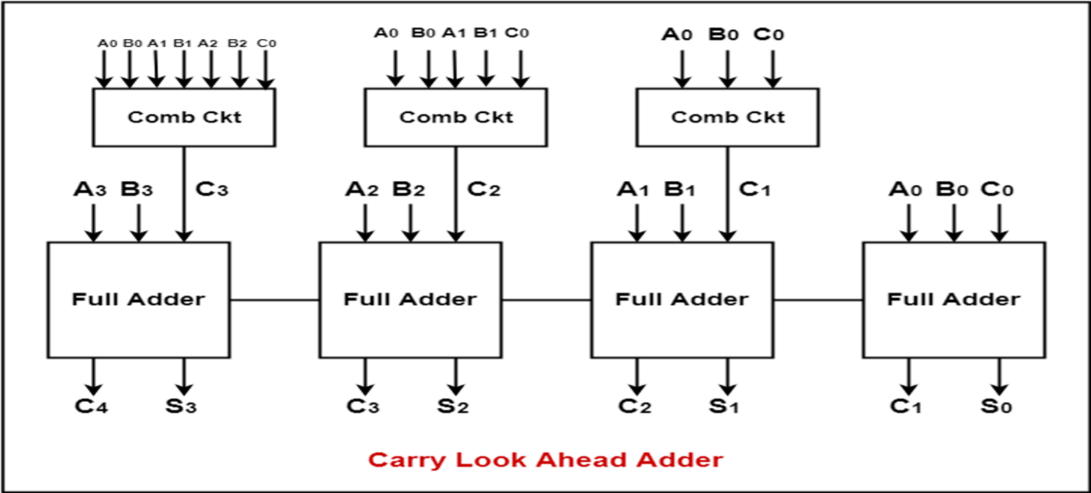

**Working of Carry Look Ahead Adder-**

• The working of carry look ahead adder is based on the principle that the carry-in of any stage full adder is independent of the carry bits generated during intermediate stages and is only dependent of the following two parameters-

1. Bits being added in the previous stages
2. Carry provided in the beginning

* Since, the above two parameters are always known, the carry-in of any stage full adder can be evaluated at any instant of time. Thus, a full adder need not wait until its carry-in is generated by its previous stage full adder.

**Example-**

Suppose we want to add two 4-bit binary numbers A3A2A1A0 and B3B2B1B0 They will be added as-

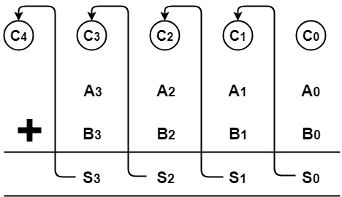

From here, we have-

C1 = C0 (A0  B0) + A0B0

C2 = C1 (A1  B1) + A1B1

C3 = C2 (A2  B2) + A2B2

C4 = C3 (A3  B3) + A3B3

For simplicity, Let-

* Gi = AiBi where G is called carry generator
* Pi = Ai  Bi where P is called carry propagator

Then, re-writing the equations, we have-

C1 = C0P0 + G0 …………. (1)

C2 = C1P1 + G1 …………. (2)

C3 = C2P2 + G2 …………. (3)

C4 = C3P3 + G3 …………. (4)

Now, let us remove C1, C2 and C3 from RHS of every equation as these are intermediate carry bits.

Substituting (1) in (2), we will get C2 in terms of C0 and then substituting (2) in (3), we will get C3 in terms of C0 and so on.

Finally, we will have the following equations showing that the carry in of any stage depends only on the bits being added in previous stages and the carry bit which was provided in the beginning-

* C1 = C0P0 + G0

* C2 = C0P0P1 + G0P1 + G1

* C3 = C0P0P1P2 + G0P1P2 + G1P2 + G2

* C4 =C0P0P1P2P3 + G0P1P2P3 + G1P2P3 + G2P3 + G3

**Need of Carry Look Ahead Adder-**

* In ripple carry adder, we have a cascade of n full adders and each full adder has to wait for its carry-in from its previous stage full adder to continue its operation.
* Thus, nth full adder has to wait until all (n-1) full adders have completed their operations which causes a delay and makes ripple carry adder extremely slow.
* The situation becomes worst when the value of n becomes very large.
* To overcome this delay, we use carry look ahead adder in which carry for each full adder is generated simultaneously without any delay.

**Advantage of Carry Look Ahead Adder-**

The advantage of carry look ahead adder is that it reduces propagation delay.

**Disadvantage of Carry Look Ahead Adder-**

* The disadvantage of carry look ahead adder is that it involves complex hardware.
* Because it involves complex hardware, it is costlier and it gets complicated as the number of bits increases.

**Time Complexity-**

Time complexity of Carry Look Ahead Adder = Θ (log n)

**RESULT:**

Thus, the study of carry look ahead adder has been done and components has been realized.

|  |  |
| --- | --- |
| EXPERIMENT: 10 |  |
| DATE: | **STUDY AND DESIGN OF ARRAY MULTIPLIER** |

**AIM:** To realize array multiplier using Basic gates

_ To realize the array multiplier circuits using basic gates

_ To realize array multiplier using four full adders

**COMPONENTS REQUIRED:**

IC 7408, IC 7486, IC 7432, Patch Cords & IC Trainer Kit.

**THEORY:**

Array multiplier is well known due to its regular structure. Multiplier circuit is based on add and shift algorithm. Each partial product is generated by the multiplication of the multiplicand with one multiplier bit. The partial product is shifted according to their bit orders and then added. The addition can be performed with normal carry propagate adder. N1 adders are required where N is the multiplier length.

ARR1 DB 20 DUP (0)

MULTIPLYING PROC

MOV AX, 0

MOV CX, 19

. WHILE CX! = 0

|  |  |  |  |  |
| --- | --- | --- | --- | --- |
|  |  |  |  | MOV DI, CX |
|  |  |  |  | MOV AL, [DIGIT_ARR1+DI] |
|  |  |  |  | ; MOV BL, 2 |
|  |  |  |  | ; MUL BL |
|  |  |  |  | SHL AX, 1 |
| 9 |  |  |  | . IF AX > 9; IF THE NEW DIGIT IS LARGER THAN |
|  |  |  |  | SUB AX, 10 |
|  |  |  |  | MOV AH, 0 |
|  |  |  |  | MOV [DIGIT_ARR1+DI], AL |
|  |  |  |  | DEC DI |
|  |  |  |  | ADD [DIGIT_ARR1+DI], 1 |
|  |  |  |  | . ELSEIF |
|  |  |  |  | MOV [DIGIT_ARR1+DI], AL; IF IT IS LESS THAN 9, |

THEN JUST INSERT IT BACK INTO THE ARRAY

. ENDIF

DEC CX

. ENDW

RET

MULTIPLYING ENDP

MULTIPLYING PROC

PUSH CX

PUSH AX

MOV CARRY, 0; START WITH EMPTY CARRY FLAG

MOV CX, 19; ARRAY SIZE

. WHILE CX > 0

MOV DI, CX; GET ELEMENT ADDRESS

MOV AL, [ARR1+DI] ; READ THE ELEMENT

SHL AL, 1 ; DOUBLING THE DIGIT

ADD AL, CARRY ; ADD THE CARRY FLAG

MOV CARRY, 0 ; CLEAR THE CARRY FLAG

.IF AL > 9 ; IF THE NEW DIGIT IS LARGER THAN 9

SUB AL, 10

MOV CARRY, 1 ; SET CARRY FLAG

MOV [ARR1+DI], AL; INSERTING THE DOUBLED DIGIT BACK TO

THE ARRAY

. ELSEIF

MOV [DIGIT_ARR1+DI], AL ; IF IT IS LESS THAN 9, INSERT IT

BACK INTO THE ARRAY

MOV CARRY, 0

. ENDIF

DEC CX

. ENDW; END OF MULTIPLICATION PROC

POP AX

POP CX

RET

MULTIPLYING ENDP

**RESULT:**

Thus, the study of array multiplier has been done and components has been realized.

|  |  |
| --- | --- |
| EXPERIMENT: 11 |  |
| DATE: | **STUDY OF BOOTH ALGORITHM** |

**Booth's algorithm**

This is a kind of algorithm which uses a more straightforward approach. This algorithm also has the benefit of the speeding up the multiplication process and it is very efficient too. Binary multiplication which has signed number uses this type of algorithms named as **Booth's algorithm**.

**Flowchart of Booth's algorithm:**

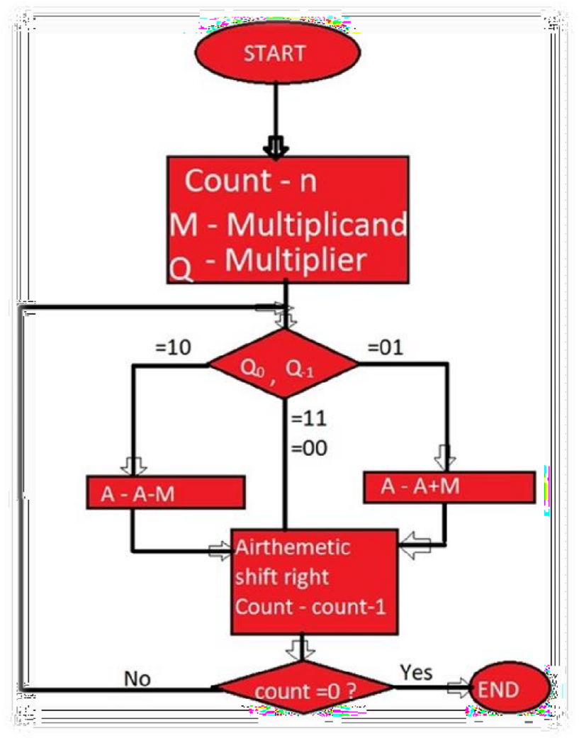

**Booth’s algorithm for two complements multiplication:**

1. Multiplier and multiplicand are placed in the Q and M register respectively.
2. Result for this will be stored in the AC and Q registers.
3. Initially, AC and Q-1 register will be 0.
4. Multiplication of a number is done in a cycle.
5. A 1-bit register Q-1 is placed right of the least significant bit Q0 of the register Q.
6. In each of the cycle, Q0 and Q-1 bits will be checked.
   1. If Q0 and Q-1 are 11 or 00 then the bits of AC, Q and Q-1 are shifted to the right by 1 bit.
   2. If the value is shown 01 then multiplicand is added to AC. After addition, AC, Q0, Q-1 register are shifted to the right by 1 bit.
   3. If the value is shown 10 then multiplicand is subtracted from AC. After subtraction AC, Q0, Q-1register is shifted to the right by 1 bit.

Basically, Booth’s algorithm uses the concept of an arithmetic right shift in which the leftmost bit is not only shifted right by 1 bit but it also remains in the original position.

**Example:** Let us multiply (-6) and (2) using Booth’s algorithm.

**Solution: (6)10 = (0110)2**

As it is given multiplicand, **M= (-6)10 =2** complement of **0110 = 1010** Multiplier, **Q= (2)10 = 0010**

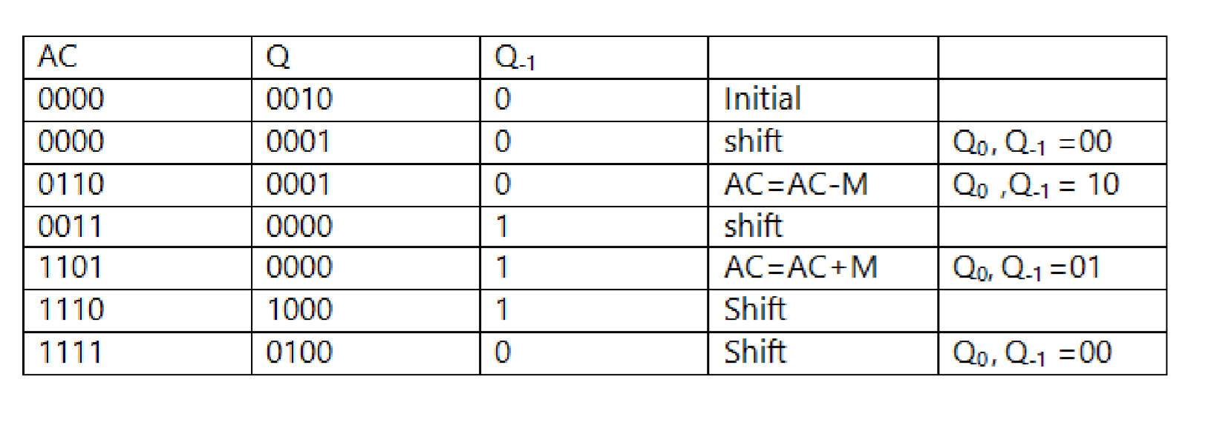

**Product by Booth’s algorithm= 1111 0100**

**RESULT:**

Thus, the study of booth algorithm has been realized.

|  |  |
| --- | --- |
| EXPERIMENT: 12 |  |
| DATE: | **PROGRAM TO CARRY OUT BOOTH ALGORITHM** |

**Booths Algorithm**

. model small

. stack

.data

prompt dB 13,10,"Enter first number to multiply. $"

prompt2db 13,10,"Enter second number to multiply. $"

resdb 13,10,"The answer is $"

ansdw 2

holddb 0

n1=0

n2=0

.code

start:

movax,seg prompt,prompt2,res,ans,hold,n1,n2

movds,ax mov ah,09h

movdx,offset prompt

int 21h

call read

mov n1,bl

mov ah,09h

mov dx, offset prompt2

int 21h

call read

mov n2,bl

call Algorithm

mov [ans],ax

movbx,ax

movdx,offset res2

mov ah,09h

int 21h

call write

mov ah,4ch

int 21h

hlt

read:

mov ah,00h

mov [hold],bl

f0:

mov al,01h

int 21h

cmp al,0dh

je Copy

movcl,al

sub cl,30h

mov al,[hold]

mov bl,0ah

mulbl

mov [hold],al

add [hold],cl

jmp f0

Copy :

movbl,[hold]

ret

Algorithm:

mov ah,0

mov al,n1

mov cx,8

mov bh,n2

clc

f1:

movbl,al

and bl,1

jnz f2

JNC f3

subah,bh

jmp

f3

f2:

jc f3

addah,bh

f3:

shr ax,1

loop f1

ret

write:

moval,bl

lea di,[ans]

mov bh,0ah

mov cl,24h

mov [di],cl

dec di

f4:

mov ah,00h

divbh

add ah,30h

mov [di],ah

dec di

cmp al,00h

jnz 4 inc di

mov ah,09h

movdx,di

int 21h

ret end start

**RESULT:**

Thus, the program of booth algorithm has been rea

|  |  |
| --- | --- |
| EXPERIMENT: 13 |  |
| DATE: | **STUDY AND PROGRAM TO CARRY SAVE**  **MULTIPLICATION** |

**Carry –Save Addition**

Consider adding six set of numbers (4 bits each in the example)

* The numbers are 1001, 0110, 1111, 0111, 1010, 0110 (all positive)
* One way is to add them pair wise, getting three results, and then adding them again

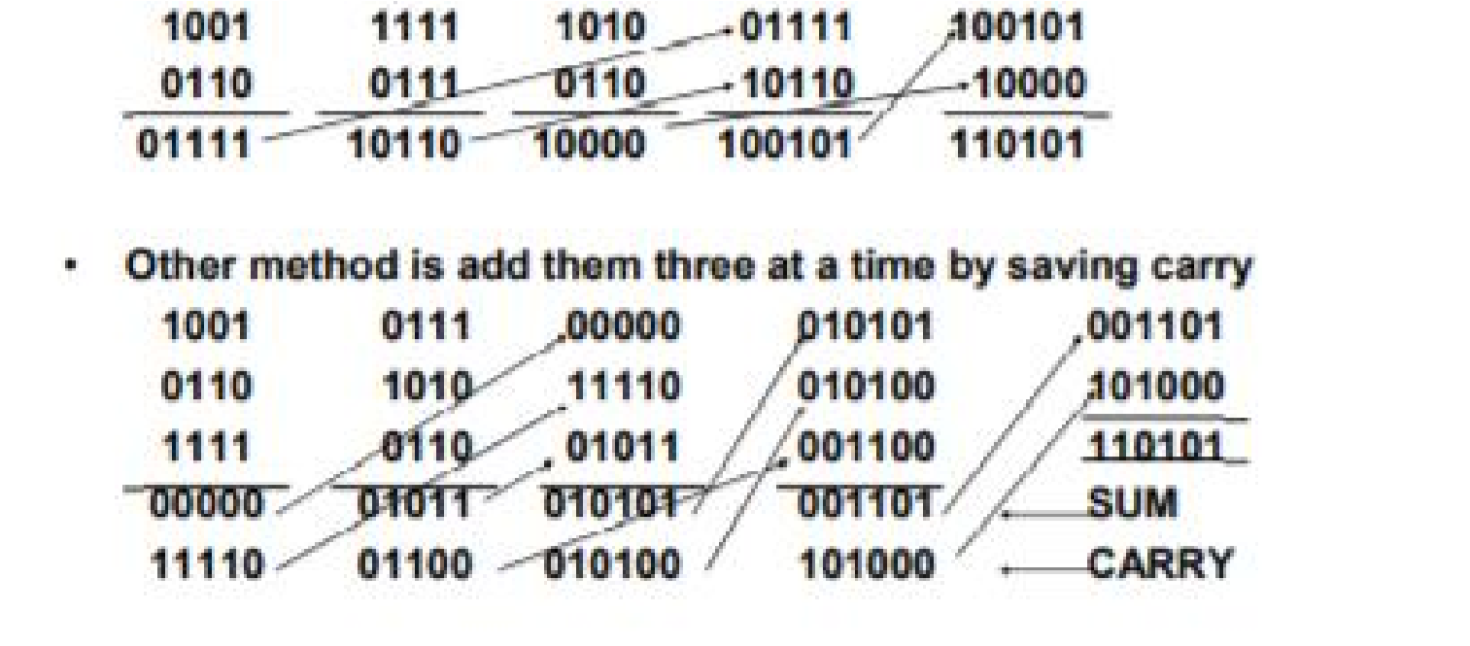

**Carry-Save Multiplication**

* n-bit carry-save adder take 1FA time for any n
* For n x n bit multiplication, n or n/2 (for 2 bit at time Booth’s encoding) partial products can be generated
* For n partial products n/3 n-bit carry save adders can be used
* This yields 2n/3 partial results
* Repeat this operation until only two partial results are remaining
* Add them using an appropriate size adder to obtain 2n bit result
* For n=32, you need 30 carry save adders in eight stages taking 8T time where T is time for one-bit full adder
* Then you need one carry-propagate or carry-look-ahead adder

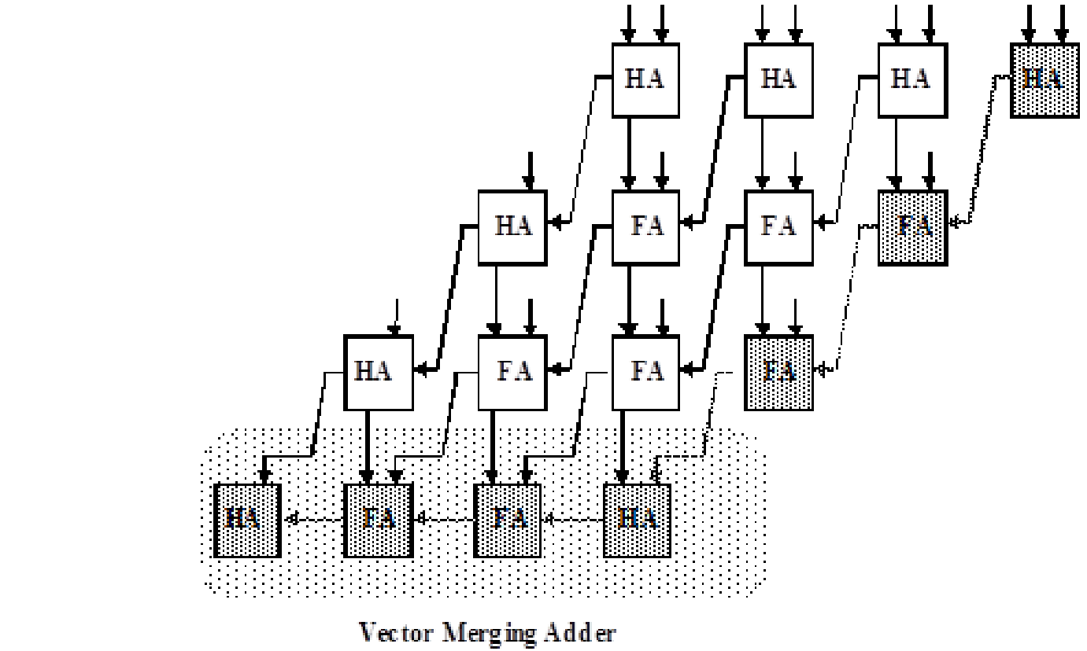

**PROGRAM TO CARRY OUT CARRY SAVE MULTIPLICATION**

**RESULT:**

Thus the study of carry lookahead adder has been done and components has been realized.

|  |  |
| --- | --- |
| EXPERIMENT : 14 |  |
| DATE : | **UNDERSTANDING OF PROCESSING UNIT AND**  **DESIGN OF PRIMITIVE PROCESSING UNIT** |

**DEFINITION**

The central processing unit (CPU) is the unit which performs most of the processing inside a computer. To control instructions and data flow to and from other parts of the computer, the CPU relies heavily on a chipset, which is a group of microchips located on the motherboard.

The CPU has two components:

* Control Unit: extracts instructions from memory and decodes and executes them
* Arithmetic Logic Unit (ALU): handles arithmetic and logical operations

To function properly, the CPU relies on the system clock, memory, secondary storage, and data and address buses.

This term is also known as a central processor, microprocessor or chip.

The CPU is the heart and brain of a computer. It receives data input, executes instructions, and processes information. It communicates with input/output (I/O) devices, which send and receive data to and from the CPU. Additionally, the CPU has an internal bus for communication with the internal cache memory, called the backside bus. The main bus for data transfer to and from the CPU, memory, chipset, and AGP socket is called the front-side bus.

The CPU contains internal memory units, which are called registers. These registers contain data, instructions, counters and addresses used in the ALU's information processing.

Some computers utilize two or more processors. These consist of separate physical CPUs located side by side on the same board or on separate boards. Each CPU has an independent interface, separate cache, and individual paths to the system front-side bus. Multiple processors are ideal for intensive parallel tasks requiring multitasking. Multicore CPUs are also common, in which a single chip contains multiple CPUs.

Technical considerations are explained in the following sections:

1. **CLOCK SPEED REQUIREMENTS FOR THE CPU**

The clock speed of the CPU is measured in Hertz and is an indication of the frequency in cycles per second of the operation of the CPU. The higher the clock speed of a CPU, the faster the performance of that CPU. For today’s personal computers, the clock speed of the processors vary from 1 GHz (Giga Hertz) to 3.5 GHz.

1. **32-bit vs. 64-bit processors**

Most of the newer computers have 64-bit compatible processor units. The move to the newer 64-bit technology emerges from the need to allow computers to support larger RAM memory chips. The 32-bit architecture would only allow the use of a 4GB RAM, and even if a larger RAM is installed in the PC, it will only be able to use 4GB and the rest will be wasted. Users with moderate computer usage, who want to simply browse the internet, write documents or send and receive e-mails can still select a 32-bit chipset. However users who heavily use their PC for multitask-heavy applications such as games and video editing will need to purchase a 64-bit chipset to optimize their computer performance.

1. **Selection of the CPU’s core and thread**

The latest CPUs to hit the market contain up to eight cores. At the moment, it is possible to purchase CPUs containing from one to eight cores. The higher the number of cores in a CPU, the faster the processes and operations it can compete at one time. There are also multiple threads on each of those processors, these allow for a certain number of concurrent tasks to be completed per processor unit.

For moderate web and applications use, the user can simply purchase a single or a dual-core processor. However, for more heavy computer use such as multi-tasking applications, gaming, video editing and multimedia processing, it is recommended that the user selects a quad-core or higher in order to optimize the computer’s performance during use.

1. **THERMAL DESIGN POWER**

Thermal design power refers to the temperature at which a processor can continue its normal operation without damaging its own internal components. When buying a CPU, aim for a higher Thermal Design Power (TPD) number, as this will allow the CPU to produce more output without damaging its core.

1. **HEAT SINK**

When you buy a CPU unit, you need to keep in mind that the unit is prone to over-heating because of the amount of operations it processes per second. Other factors also influence and increase the over-heating of the CPU, such as the internal design of the computer’s components, the distance between those components, the possibility of aeration of the CPU and the ambient temperature of the room or location where the PC is stored. If the ambient temperature is above average in hot summer days, it might also contribute to the over-heating of the processor. For these reasons, it is highly recommended that all processors have a heat sink installed to help cooling them down and preventing them from over-heating which will optimize their performance.

When the CPU in the computer experiences overheating and there is no heat sink attached to solve this problem, the user will start experiencing a range of erratic behaviour on the computer, such as computer lock ups, sudden reboots, application errors, etc. Keep in mind that the heat sink you buy should be compatible with the type of processor installed in your computer.

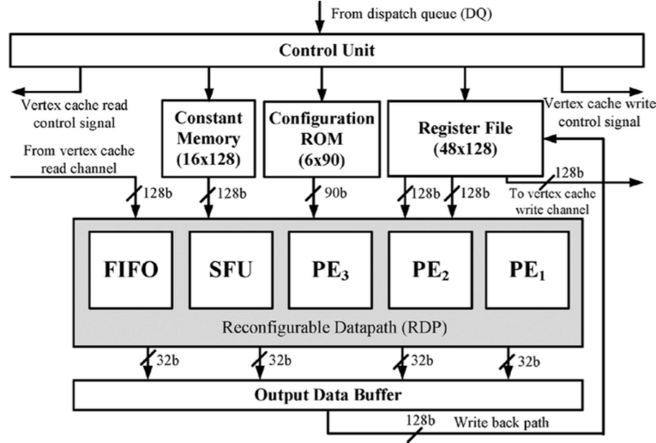

**DESIGN OF PRIMITIVE PROCESSING UNIT**

**Control Unit** is the part of the computer’s central processing unit (CPU), which directs the operation of the processor. It was included as part of the [Von Neumann Architecture](https://www.geeksforgeeks.org/computer-organization-von-neumann-architecture/) by John von Neumann. It is the responsibility of the Control Unit to tell the computer’s memory, arithmetic/logic unit and input and output devices how to respond to the instructions that have been sent to the processor. It fetches internal instructions of the programs from the main memory to the processor instruction register, and based on this register contents, the control unit generates a control signal that supervises the execution of these instructions.

A control unit works by receiving input information to which it converts into control signals, which are then sent to the central processor. The computer’s processor then tells the attached hardware what operations to perform. The functions that a control unit performs are dependent on the type of CPU because the architecture of CPU varies from manufacturer to manufacturer. Examples of devices that require a CU are:

* Control Processing Units(CPUs)
* Graphics Processing Units(GPUs)

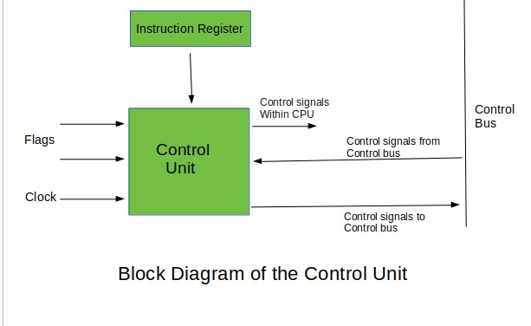

**FUNCTIONS OF THE CONTROL UNIT –**

1. It coordinates the sequence of data movements into, out of, and between a processor’s many sub-units.
2. It interprets instructions.
3. It controls data flow inside the processor.
4. It receives external instructions or commands to which it converts to sequence of control signals.
5. It controls many execution units(i.e. ALU, data buffers and registers) contained within a CPU.
6. It also handles multiple tasks, such as fetching, decoding, execution handling and storing results.

**Types of Control Unit –**

There are two types of control units: Hardwired control unit and Micro programmable control unit.

1. **Hardwired Control Unit**

In the Hardwired control unit, the control signals that are important for instruction execution control are generated by specially designed hardware logical circuits, in which we can not modify the signal generation method without physical change of the circuit structure. The operation code of an instruction contains the basic data for control signal generation. In the instruction decoder, the operation code is decoded. The instruction decoder constitutes a set of many decoders that decode different fields of the instruction opcode.

As a result, few output lines going out from the instruction decoder obtains active signal values. These output lines are connected to the inputs of the matrix that generates control signals for executive units of the computer. These matrixes implements logical combinations of the decoded signals from the instruction opcode with the outputs from the matrix that generates signals representing consecutive control unit states and with signals coming from the outside of the processor, e.g. interrupt signals. The matrices are built in a similar way as a programmable logic arrays.

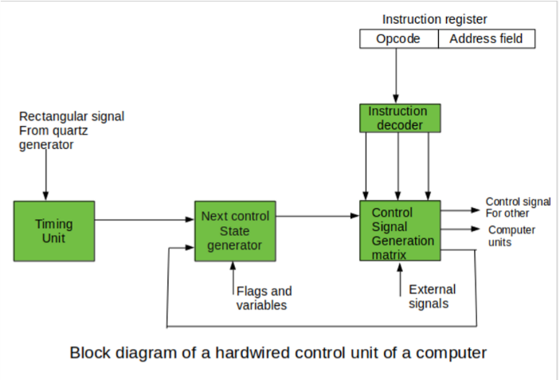

Control signals for an instruction execution have to be generated not in a single time point but during the entire time interval that corresponds to the instruction execution cycle. Following the structure of this cycle, the suitable sequence of internal states is organized in the control unit.

A number of signals generated by the control signal generator matrix are sent back to inputs of the next control state generator matrix. This matrix combines these signals with the timing signals, which are generated by the timing unit based on the rectangular patterns usually supplied by the quartz generator. When a new instruction arrives at the control unit, the control units is in the initial state of new instruction fetching. Instruction decoding allows the control unit enters the first state relating execution of the new instruction, which lasts as long as the timing signals and other input signals as flags and state information of the computer remain unaltered. A change of any of the earlier mentioned signals stimulates the change of the control unit state.

This causes that a new respective input is generated for the control signal generator matrix. When an external signal appears, (e.g. an interrupt) the control unit takes entry into a next control state that is the state concerned with the reaction to this external signal (e.g. interrupt processing). The values of flags and state variables of the computer are used to select suitable states for the instruction execution cycle.

The last states in the cycle are control states that commence fetching the next instruction of the program: sending the program counter content to the main memory address buffer register and next, reading the instruction word to the instruction register of computer. When the ongoing instruction is the stop instruction that ends program execution, the control unit enters an operating system state, in which it waits for a next user directive.

1. **Microprogrammable control unit**

The fundamental difference between these unit structures and the structure of the hardwired control unit is the existence of the control store that is used for storing words containing encoded control signals mandatory for instruction execution.

In microprogrammed control units, subsequent instruction words are fetched into the instruction register in a normal way. However, the operation code of each instruction is not directly decoded to enable immediate control signal generation but it comprises the initial address of a microprogram contained in the control store.

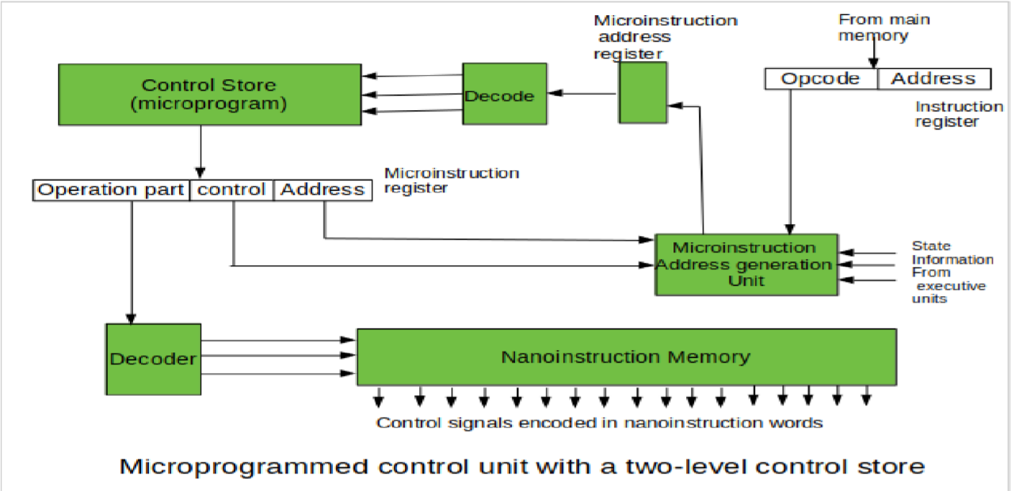

**RESULT:**

Thus the study of understanding processing unit,design of primitive processing unit has been done and components has been realized.

|  |  |
| --- | --- |
| EXPERIMENT : 15 |  |
| DATE : | **UNDERSTANDING OF PIPELINE CONCEPT AND**  **DESIGN OF BASIC PIPELINE** |

**WHAT IS PIPELINING?**

Pipelining is the process of accumulating instruction from the processor through a pipeline. It allows storing and executing instructions in an orderly process. It is also known as pipeline processing.

Pipelining is a technique where multiple instructions are overlapped during execution. Pipeline is divided into stages and these stages are connected with one another to form a pipe like structure. Instructions enter from one end and exit from another end.

Pipelining increases the overall instruction throughput.

In pipeline system, each segment consists of an input register followed by a combinational circuit. The register is used to hold data and combinational circuit performs operations on it. The output of combinational circuit is applied to the input register of the next segment.

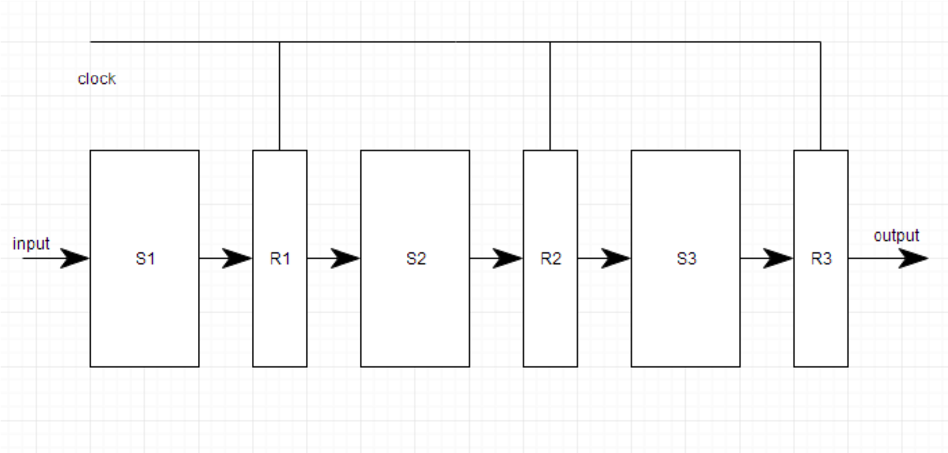

Pipeline system is like the modern day assembly line setup in factories. For example in a car manufacturing industry, huge assembly lines are setup and at each point, there are robotic arms to perform a certain task, and then the car moves on ahead to the next arm.

**TYPES OF PIPELINE**

It is divided into 2 categories:

1. Arithmetic Pipeline
2. Instruction Pipeline

**ARITHMETIC PIPELINE**

Arithmetic pipelines are usually found in most of the computers. They are used for floating point operations, multiplication of fixed point numbers etc. For example: The input to the Floating Point Adder pipeline is:

1. = A*2^a
2. = B*2^b

Here A and B are mantissas (significant digit of floating point numbers), while a and b are exponents.

The floating point addition and subtraction is done in 4 parts:

1. Compare the exponents.
2. Align the mantissas.
3. Add or subtract mantissas
4. Produce the result.

Registers are used for storing the intermediate results between the above operations.

**Instruction Pipeline**

In this a stream of instructions can be executed by overlapping *fetch*, *decode* and *execute* phases of an instruction cycle. This type of technique is used to increase the throughput of the computer system.

An instruction pipeline reads instruction from the memory while previous instructions are being executed in other segments of the pipeline. Thus we can execute multiple instructions simultaneously. The pipeline will be more efficient if the instruction cycle is divided into segments of equal duration.

**PIPELINE CONFLICTS**

There are some factors that cause the pipeline to deviate its normal performance. Some of these factors are given below:

1. *Timing Variations*

All stages cannot take same amount of time. This problem generally occurs in instruction processing where different instructions have different operand requirements and thus different processing time.

1. *Data Hazards*

When several instructions are in partial execution, and if they reference same data then the problem arises. We must ensure that next instruction does not attempt to access data before the current instruction, because this will lead to incorrect results.

1. *Branching*

In order to fetch and execute the next instruction, we must know what that instruction is. If the present instruction is a conditional branch, and its result will lead us to the next instruction, then the next instruction may not be known until the current one is processed.

1. *Interrupts*

Interrupts set unwanted instruction into the instruction stream. Interrupts effect the execution of instruction.

1. *Data Dependency*

It arises when an instruction depends upon the result of a previous instruction but this result is not yet available.

**ADVANTAGES OF PIPELINING**:

1. The cycle time of the processor is reduced.
2. It increases the throughput of the system
3. It makes the system reliable.

**DISADVANTAGES OF PIPELINING:**

1. The design of pipelined processor is complex and costly to manufacture.
2. The instruction latency is more.
   1. In 8086, to speed up the execution of program, the instruction fetching and execution of instructions are overlapped with each other.
   2. This process of fetching the next instruction when the present instruction is being executed is called as pipelining.
   3. In pipelining, when the nth instruction is executed, the (n+1) th instruction is fetched and thus the processing speed is increased.
   4. Pipelining has become possible due to the use of queue.
   5. BIU (Bus Interfacing Unit) fills in the queue until the entire queue is full.
   6. BIU restarts filling in the queue when at least two locations of queue are vacant.

**The Instruction Queue:**

* 1. The execution unit (EU) is supposed to decode or execute an instruction.
  2. Decoding does not require the use of buses.
  3. When EU is busy in decoding and executing an instruction, the BIU fetches up to six instruction bytes for the next instructions.
  4. These bytes are called as the pre-fetched bytes and they are stored in a first in first out (FIFO) register set, which is called as a queue.

**SIGNIFICANCE OF QUEUE:**

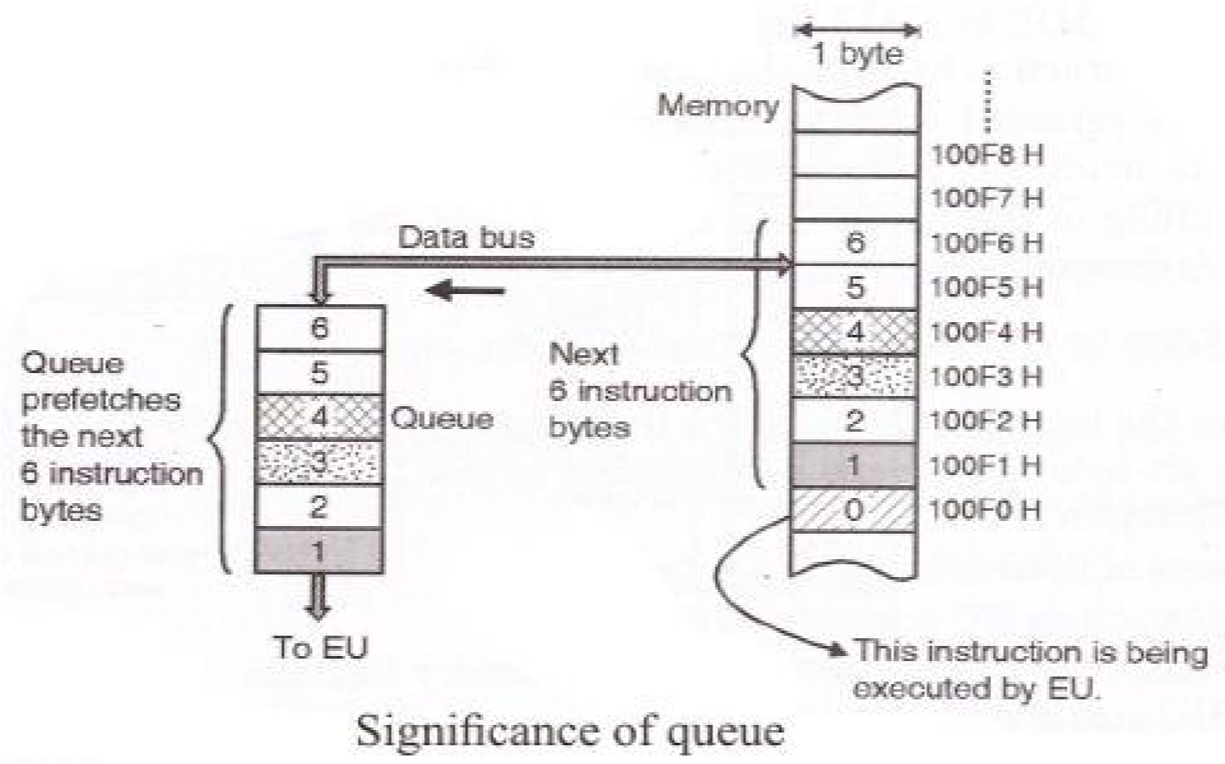

* 1. As shown in the above figure, while the EU is busy in decoding the instruction corresponding to memory location 100F0, the BIU fetches the next six instruction bytes from locations 100F1 to 100F6 numbered as 1 to 6.
  2. These instruction bytes are stored in the 6 byte queue on the first in first out (FIFO) basis.
  3. When EU completes the execution of the existing instruction and becomes ready for the next instruction, it simply reads the instruction bytes in the sequence 1, 2…. from the Queue.
  4. Thus the Queue will always hold the instruction bytes of the next instructions to be executed by the EU.

**ADVANTAGES OF PIPELINING:**

* 1. The EU always reads the next instruction byte from the queue in BIU. This is much faster than sending out an address to the memory and waiting for the next instruction byte to come.
  2. In short pipelining eliminates the waiting time of EU and speeds up the processing.
  3. The 8086 BIU will not initiate a fetch unless and until there are two empty bytes in its queue. 8086 BIU normally obtains two instruction bytes per fetch.

**DISADVANTAGES OF PIPELINING:**

* 1. While pipelining can severely cut the time taken to execute a program, there are problems that cause it to not work as well as it perhaps should.
  2. The three stages of the instruction execution process do not necessarily take an equal amount of time, with the time taken for 'execute' being generally longer than 'fetch'.

This makes it much harder to synchronise the various stages of the different instructions.

* 1. Also, some instructions may be dependent on the results of other earlier instructions. This can arise when data produced earlier needs to be used or when a conditional branch based on a previous outcome is used.

**RESULT:**

Thus, the study and design of understanding pipeline concepts has been done and components has been realized.